Step 1. Install the latest version of GPT4All Chat from [GPT4All Website](https://gpt4all.io/).

Step 2. Go to Settings > LocalDocs tab.

Step 3. Download the SBert model

Step 4. Configure a collection (folder) on your computer that contains the files your LLM should have access to. You can alter the contents of the folder/directory at anytime. As you add more files to your collection, your LLM will dynamically be able to access them.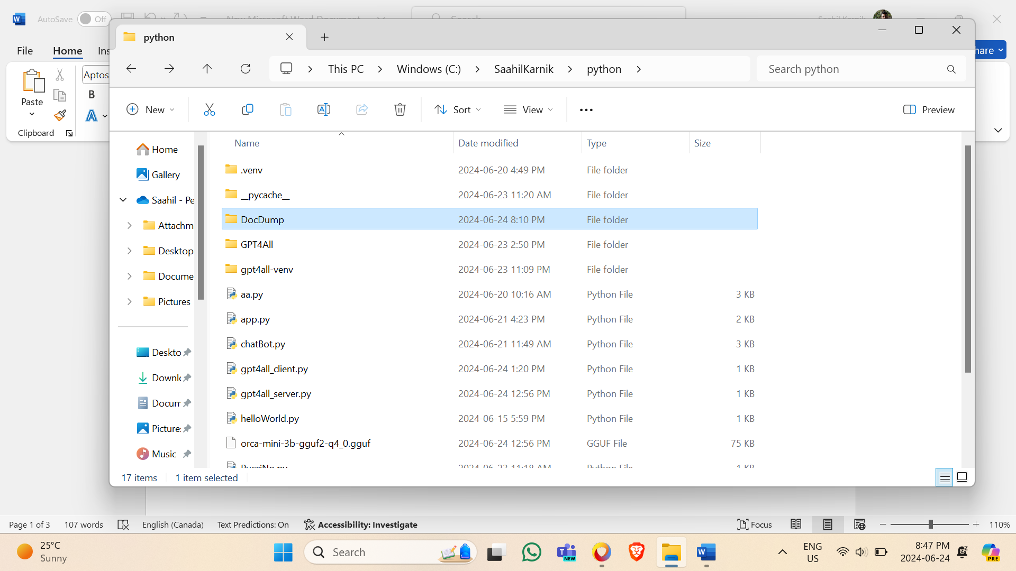

Step 5. Spin up a chat session with any LLM.

Step 6. At the top right, click the database icon and select which collection you want your LLM to know about during your chat session.

